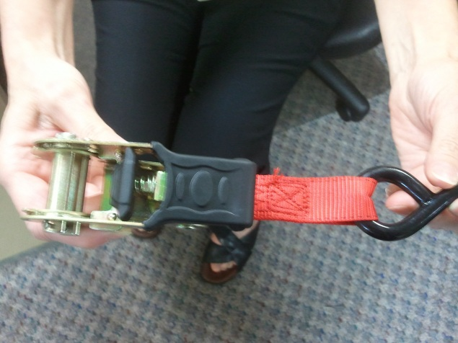

Holding the short end of the ratchet assembly in one hand, depress the spring loaded Ratchet release button on the top of the ratchet Handle with one or two fingers.

Make sure the ratchet is in the full open position. It should be nearly horizontal in your hand.

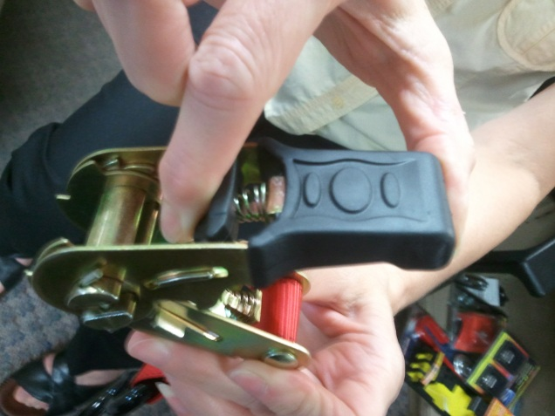

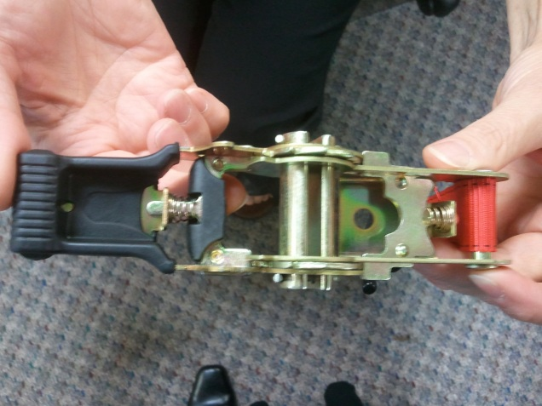

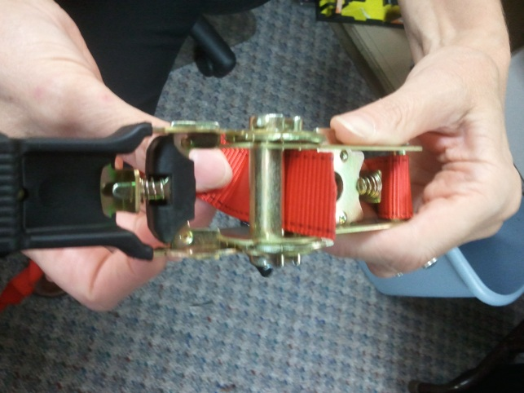

Once the ratchet is fully open, take the long end of the ratchet assembly and feed the loose webbing through the end of the spindle in the middle of the ratchet.

Pull at least 6” of webbing through the center to start with.

Then take the loose piece of webbing and feed down through the empty space between the spindle and the rubber ratchet handle.

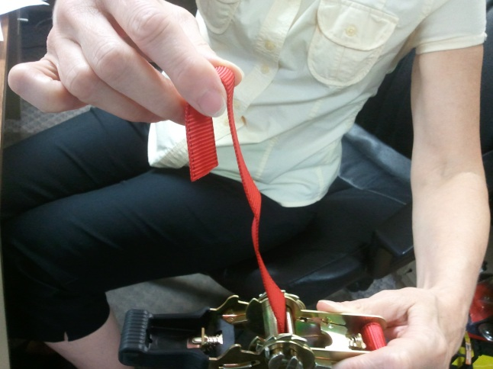

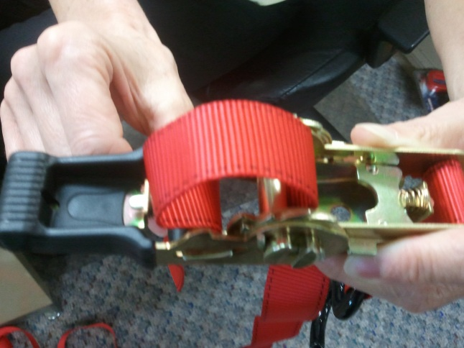

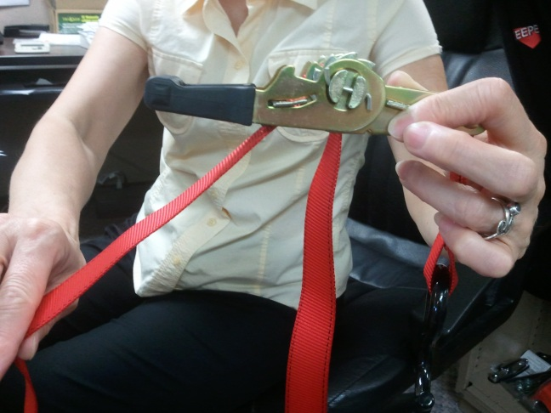

At this point, pull all the loose webbing through these two points until the webbing is taut against the object you are trying to tie down.

Close the ratchet handle completely. Do not press the ratchet release button when closing the ratchet.

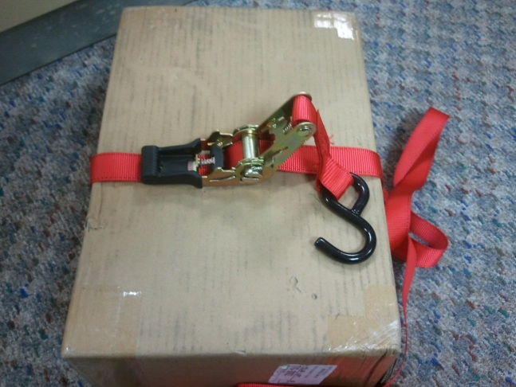

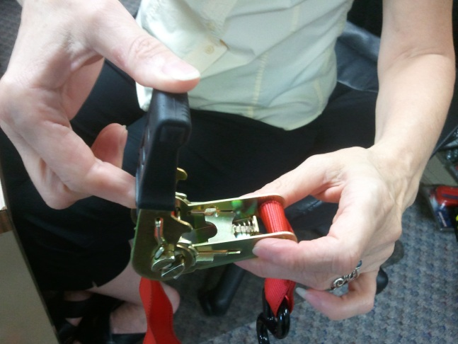

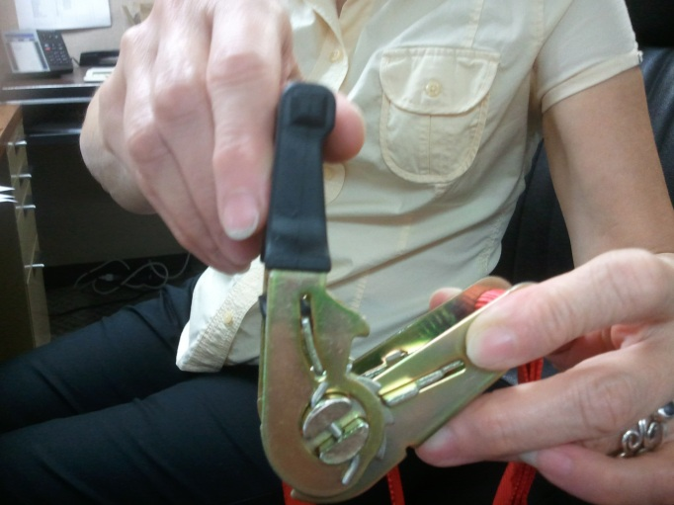

Start to move the ratchet handle up and down in short quick motions being careful not to press the ratchet release button on the top of the ratchet.

You will begin to see the webbing wrap around the center of the Ratchet spindle.

There should be no more than 4 layers of webbing wrapped around the spindle. Any more may cause the ratchet to jam.

