OVAL WALL LIGHT
INSTALLATION INSTRUCTIONS
MODEL NO. 7971-01

Congratulations on your purchase of a Newport Coastal ‘Oval Wall Light’. You have purchased a safe, dependable, and easy-to-install outdoor lighting system. You can use this fixture at home for outdoor lighting applications.

WHAT’S INCLUDED:
A – Mounting Bar B – ½” Mounting Bar Screws (2) C – Fixture Base D – Wire Connectors (3) E – 1” Fixture Mounting Screw (1) F – Washer G – Diffuser H - Grill J – Grill Mounting Screws (4) Tools Required: Phillips Screwdriver, Silicon Sealant or Caulk
k
IMPORTANT SAFETY INFORMATION
THIS PRODUCT MUST BE INSTALLED IN ACCORDANCE WITH ALL APPLICABLE INSTALLATION CODES.
- IF YOU ARE NOT FAMILIAR WITH ELECTRICAL WIRING, IT IS RECOMMENDED THAT YOU SECURE THE SERVICES OF A WELL QUALIFIED ELECTRICIAN WHO CAN ASSURE THAT THIS INSTALLATION MEETS LOCAL, STATE, AND NATIONAL CODES.
- BE SURE POWER IS TURNED OFF AT THE MAIN POWER PANEL OR FUSE BOX PRIOR TO INSTALLATION OR REPLACING FIXTURE.
- Before installing this fixture, be sure to check with local ordinances regarding approved outdoor lighting. This fixture style may not be allowed in some areas.
- This fixture is for outdoor use and wall mount application only.
- This fixture should be mounted to a grounded junction box marked for use in wet locations.
- The electrical system and the method of connecting the fixture to the system must be in accordance with local, state, and national electric codes.
- This fixture is to be connected to a 120 volt, 60 Hz power source. Connecting to a different power source may create a hazard and will void the warranty.
- This fixture is suitable for wet locations.
- Clean only with mild soap and water. Avoid spraying with cleansers, insecticides, and pesticides that are petroleum base product. These will degrade luminaire.
- Do not use near or around flammable/combustible material or liquids.
- When replacing the lamp (bulb), use only Type A medium base lamp (bulb) – 60 Watt Maximum. Never use a lamp (bulb) with a higher wattage than the stated maximum allowed on the fixture. Using a higher wattage lamp may cause a fire hazard and/or damage to the unit.
- The lamp (bulb) and fixture can get hot during use. Turn off the power and allow the fixture to cool down for at least 10 minutes prior to working on the unit.

PRIOR TO INSTALLATION
Carefully read through the entire installation instructions before installing this outdoor lighting fixture.
WARNING: BE SURE POWER IS OFF AT MAIN POWER PANEL/FUSE BOX BEFORE INSTALLING OR REPLACING FIXTURE. THIS PRODUCT MUST BE INSTALLED IN ACCORDANCE WITH THE APPLICABLE INSTALLATION CODES BY A PERSON FAMILIAR WITH THE CONSTRUCTION AND OPERATION OF THE PRODUCT AND THE HAZARDS INVOLVED.

INSTALLATION INSTRUCTIONS
BE SURE POWER IS TURNED OFF AT THE MAIN POWER PANEL OR FUSE BOX PRIOR TO INSTALLATION OR REPLACING FIXTURE.
- Remove old lighting fixture. If installing at a new location, contact a qualified electrician.
- Attach Mounting Bar (A) to junction box with two (2) ½” Mounting Bar Screws (B) – Figure 1.
- WIRING – See Figure 2.
- Connect the Black wire from Fixture Base (A) to the Black wire of the supply circuit using Wire Connectors (D).
- Connect the White wire from Fixture Base (A) to the White wire of the supply circuit using Wire Connectors (D).
- Connect bare fixture ground wire to ground wire from the junction box using Wire Connectors (D). NEVER CONNECT GROUND WIRE TO BLACK OR WHITE POWER SUPPLY WIRES.
- Insert wires into junction box.
- Position Fixture Base (C) over junction box and secure in place with 1” Fixture Mounting Screw (E) and Washer (F) – Figure 3.
- Install Type A Medium Base lamp (bulb – not included) into socket housing. Lamp wattage NOT to exceed 60 Watts. See ‘Installing or Replacing Lamp’ Section.
- Place Diffuser (G) on Fixture Base (C), then place Grill (H) over Diffuser and attach to Fixture Base with four (4) ½” Grill Mounting Screws (J) – Figure 4.
- IMPORTANT: Apply a weatherproof silicone caulk or sealant around the fixture base to reduce chance of water leaking into the fixture body.
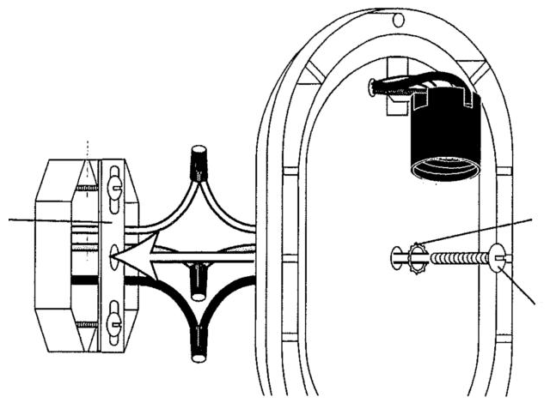
- Turn ON the power.
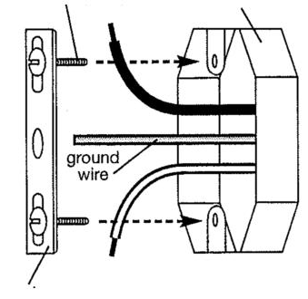
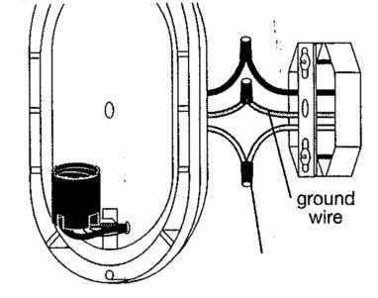

FIGURE 3
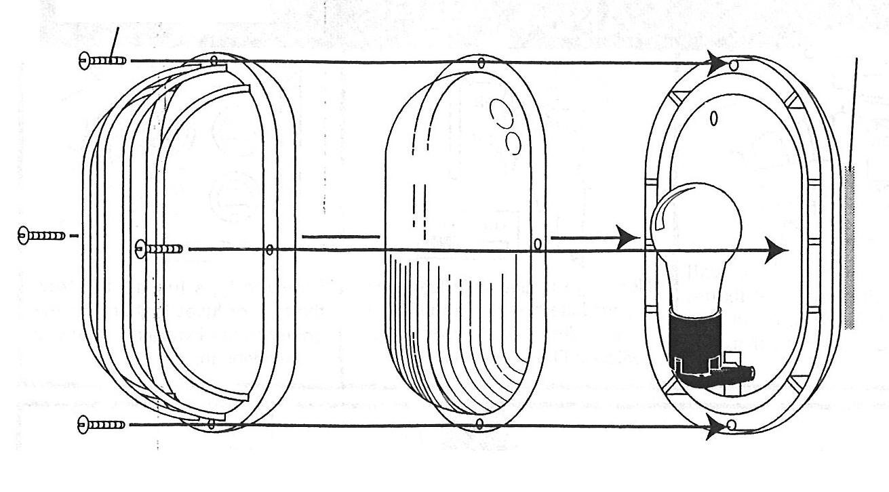
FIGURE 1 FIGURE 2 Note: Fixture can be mounted in Vertical (shown) or Horizontal Orientation.

INSTALLING OR REPLACING LAMPS
- WARNING: Turn off power and allow fixture to cool down for at 10 minutes prior to working on unit.
- Remove Grill (H) and Diffuser (G) by removing four (4) ½ “ Grill Mounting Screws (J).
- When replacing lamp (bulb), use only a Type A Medium Base lamp (bulb) - 60 watts maximum.
- To remove existing lamp (bulb) gently twist lamp counterclockwise until it becomes
free of fixture. Install new lamp (bulb) by turning clockwise. Do not over-tighten lamp (bulb).
- Replace Grill (H) and Diffuser (G).

TROUBLESHOOTING
Does not function at all
● Make sure wall switch (if applicable) is ON and that the wiring is correct.
● Check that the circuit breaker, fuse, and main circuit breaker or main power switch are ON.
FIGURE 4
LIMITED LIFETIME WARRANTY
This product is warranted to be free from defects in material and workmanship for the life of the product. If a defect in material or workmanship occurs, call 1-800-562-5625 for instructions on how to have the defective product repaired or replaced free of charge.
LIMITATIONS
• This warranty only covers Newport Coastal assembled lighting products and is not extended to other components or equipment that is used in conjunction with the product.
• This warranty is extended to original purchaser of the product. A purchase receipt or other approved proof of purchase is required before warranty service will be rendered.
• Unauthorized service or modification to this product or any furnished component will void this warranty in its entirety.
• THIS WARRANTY IS EXPRESSLY IN LIEU OF ALL OTHER WARRANTIES, EXPRESSED OR IMPLIED, INCLUDING ANY WARRANTY, REPRESENTATION OR CONDITION OF MERCHANTABILITY OR THAT THE PRODUCTS ARE FIT FOR ANY PARTICULAR PURPOSE OR USE, AND SPECIFICALLY IN LIEU OF ALL SPECIAL, INDIRECT, INCIDENTAL, OR CONSEQUENTIAL DAMAGES (INCLUDING BUT NOT LIMITED TO ANY LOSS OF BUSINESS OR PROFITS, WHETHER OR NOT FORESEEABLE) RESULTING FROM THE USE OF THE PRODUCT OR ARISING OUT OF ANY BREACH OF THIS WARRANTY.
Some states or provinces do not allow the exclusion of incidental or consequential damages, so the above limitation or exclusion may not apply.
• This warranty gives you specific rights, and you may also have other rights that vary from state to state.

NOT COVERED
• Failure of product as a result of an accident, misuse, abuse, negligence, alteration, or faulty installation, or any other failure not relating to faulty material or workmanship.
• Damage caused by separately purchased replacement bulbs.
• Corrosion and discoloration of brass components.
• Reimbursement for inconvenience, installation, setup time, loss of use, or unauthorized service.
Made in China
Hampton Products International Corp © 2008 Hampton Products International Corp
50 Icon, Foothill Ranch, CA 92610-3000 999-60390 REVA 12/08

