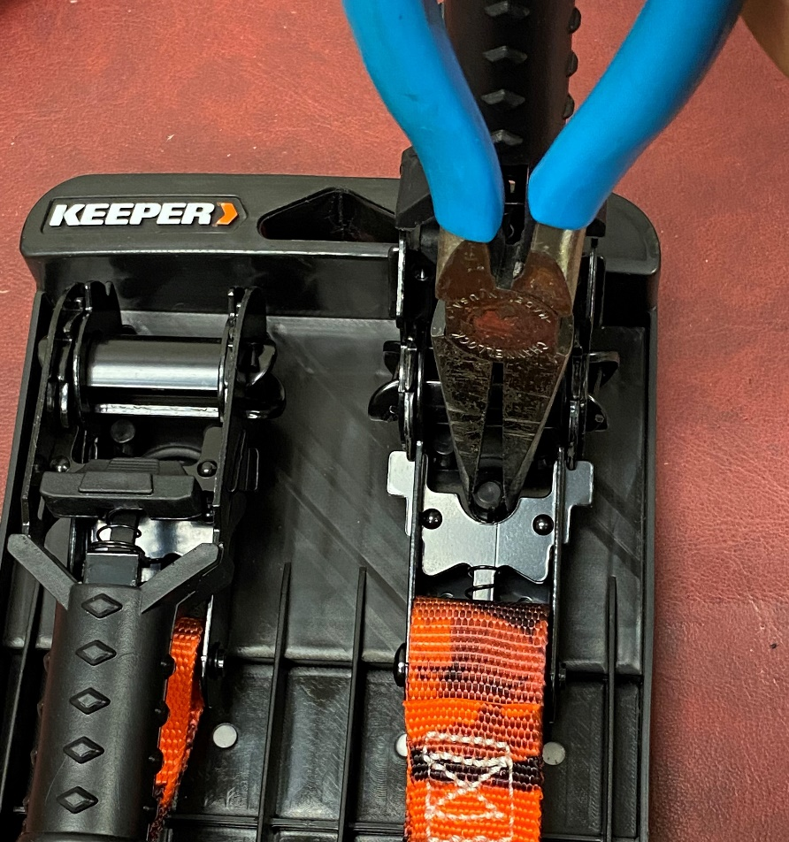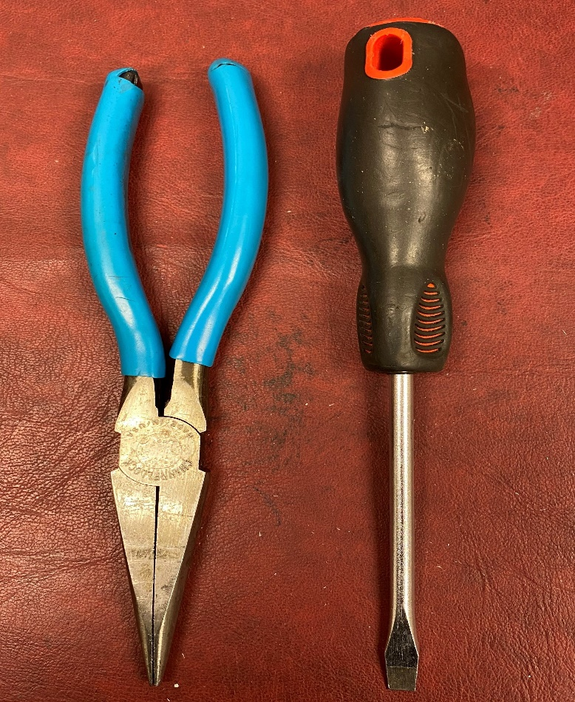

Use your Needle Nose Pliers to squeeze the middle of the mounting post and pull up.

Tools to use: Needle Nose Pliers and Flat Head Screwdriver.

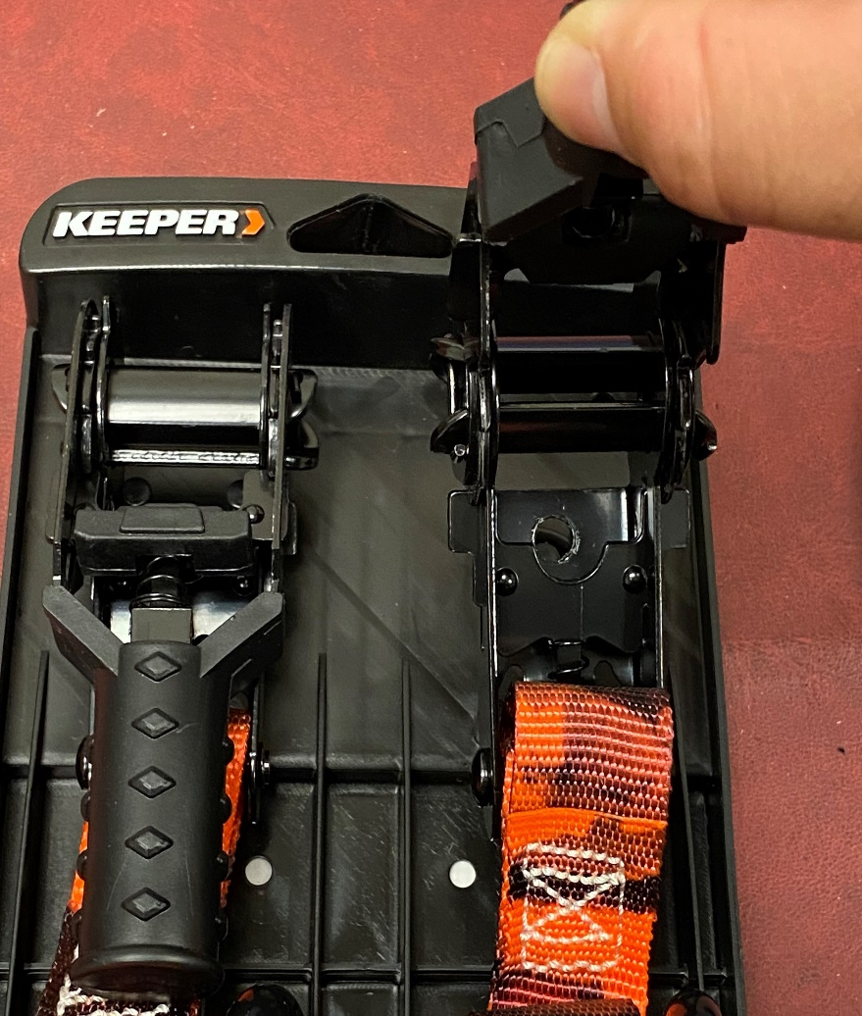

The Ratchet Strap has now been released.

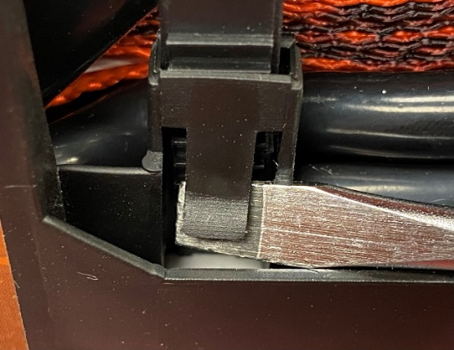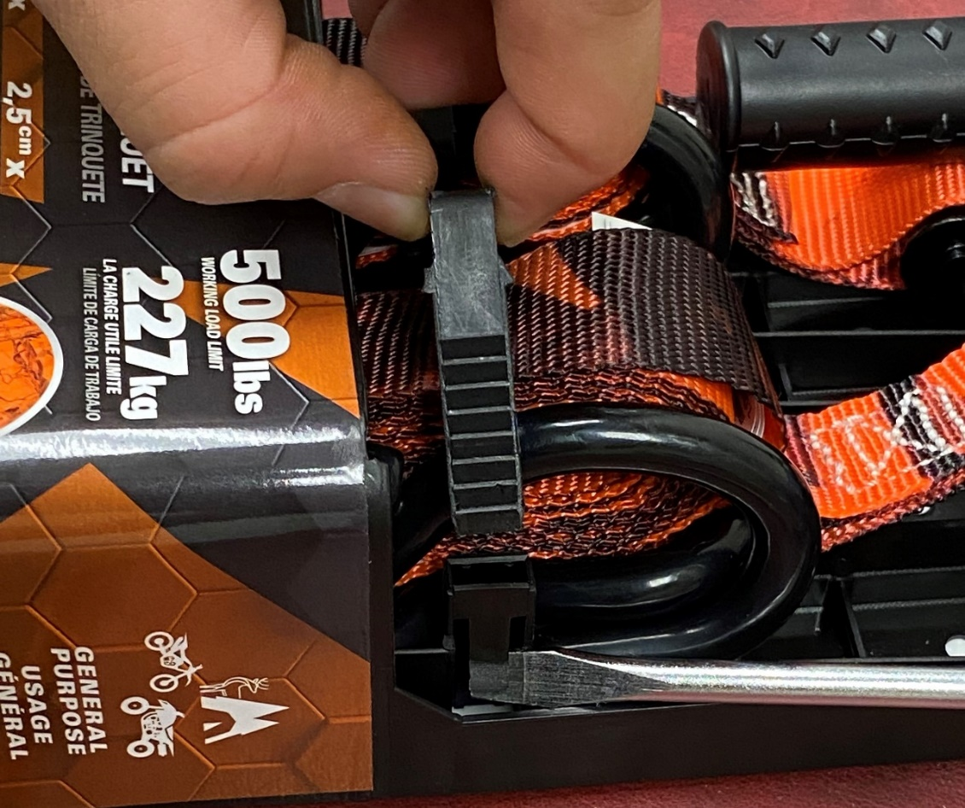

Pull on the strap at the same time as your pulling up on the bottom of the flap Release the strap and free the Webbing and Hook.

Take your flat head screwdriver or anything flat and insert it on the bottom of the flap and pull up.

